Workday Job Aid – Employee Self Service
Completing Your Annual Performance Review

The instructions below will guide you through completing the Annual Performance Review

- Log into Workday (https://www.myworkday.com/theclaremontcolleges/d/home.htmld) with your CMC login credentials.
- To access the first task and complete the employee self-evaluation step, go to your Workday Tasks by clicking on the mailbox icon from the top right-hand corner of the screen.
  - Alternatively, the employee self-evaluation will be accessible from your Workday home page under the Awaiting Your Action section
- Locate the task named Self Evaluation: CMC Annual Performance Review for Staff and click Get Started to start your self-review.
- Complete the self-evaluation sections:
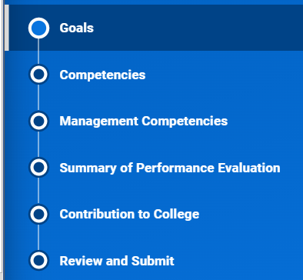

Goals
- Click Add under Goals to enter a goal. We recommend that at least one goal be entered. After you click Add, new fields will appear, allowing you to enter additional details about the goal
  - In the Goal text box, enter a title for the goal you are adding.
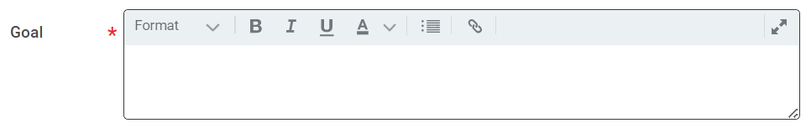
  - Select a Status for the goal
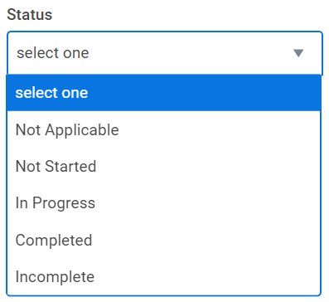
  - Enter a Rating for the Goal
  - Click Add.
- Repeat step 1 for each additional goal.
- Click Next when finished entering goals.

Competencies
- For each Competency, please select a rating in the Proficiency Rating field
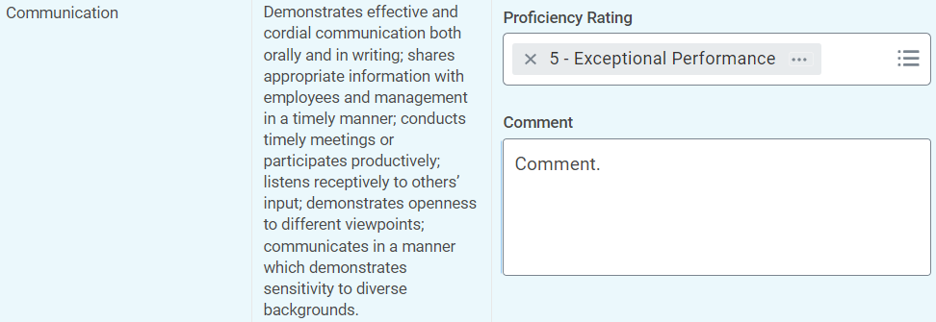
- Each competency also includes a Comment box, where you can add explanations and additional notes on your rating, as well as provide specific examples from the evaluation period.
- Once you have provided the Proficiency Rating for each Competency, the competency ratings will be averaged in the Employee Summary section.
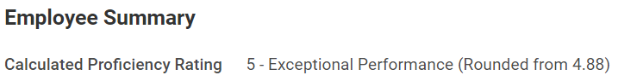
- Click Next when finished rating the Competencies.

Management Competencies
Note: If you supervise one or more employees, please rate your performance as it relates to each competency. Add explanatory comments and specific examples or illustrations from the evaluation period.
If you do not supervise any employees, please select Does Not Apply as the rating option for each competency.
- For each Competency, please select a rating in the Proficiency Rating field (or select 0 – Does Not Apply if you do not supervise employees)
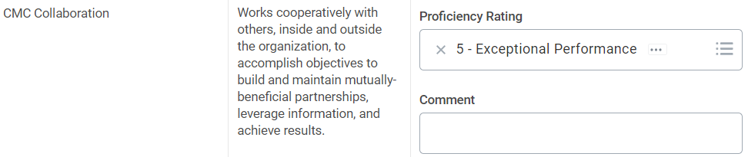
- Each management competency also includes a Comment box, where you can add explanations and additional notes on your rating, as well as provide specific examples from the evaluation period.
- Once you have provided the Proficiency Rating for each Competency, the competency ratings will be averaged in the Employee Summary section.
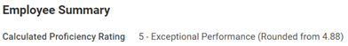
- Click Next when finished rating the Management Competencies.

Summary of Performance Evaluation
- For the Summary of Performance Evaluation, select an overall rating in the Rating field.
  - Note that you will see the calculated average rating from the previous sections
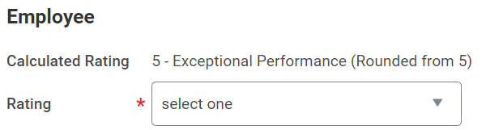
- You may also provide any concluding thoughts or comments regarding your performance to support your rating.
- Click Next when complete.

Contribution to College
- Please provide an Answer to the Employee Contribution to College prompt.
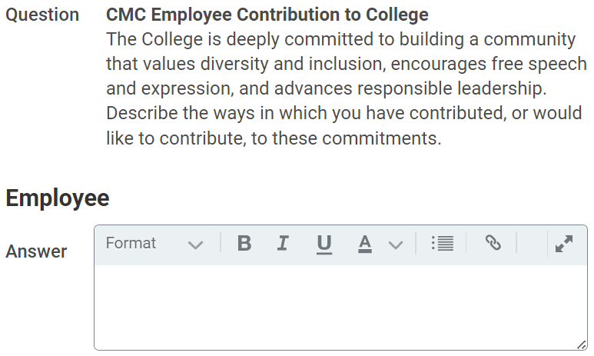
- Click Next when complete.

Review and Submit
- Please review your responses to the self-evaluation for completeness and accuracy.
  - If you need to make updates to any responses, you may do so by clicking on the section in the left-hand navigation menu.
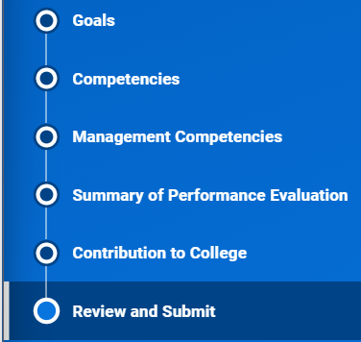
- When you are finished making updates to your review and are ready to submit, click Submit.

Next Steps
- The performance review will now route to your manager to complete the Manager Evaluation. Once this is complete, your performance review will route through a few approvals by your manager’s supervisor and CMC Human Resources.
- Once the performance review is fully completed and approved, your manager will coordinate a time to meet with you to discuss the evaluation.
- After you meet with your manager, you will receive a new task in Workday.
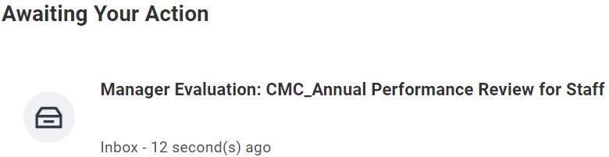
- Open the new task (Provide Employee Review Comments) and click Get Started
- You will have one last opportunity to review your performance evaluation in the Summary Section.
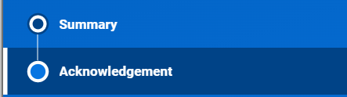
- When you have reviewed the performance evaluation and have had the opportunity to discuss it with your manager, please Acknowledge the review by navigating to the Acknowledgement section on the left-hand menu, clicking in the Status drop-down menu and selecting Acknowledge Review.
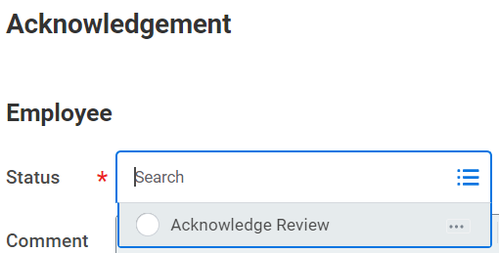
- Click Submit when you are done.

