Workday Job Aid – Manager Self Service for Service Staff
Completing Your Direct Report’s Annual Performance Review

The instructions below will guide you through completing the manager’s portion of the Annual Performance Review

- Once your direct report has completed their self-evaluation, you will receive a task in Workday for the manager’s evaluation.
- Log into Workday (https://www.myworkday.com/theclaremontcolleges/d/home.htmld) with your CMC login credentials.
- To access the first task and complete the manager evaluation step, go to your Workday Tasks by clicking on the mailbox icon from the top right-hand corner of the screen.
  - Alternatively, the manager evaluation will be accessible from your Workday home page under the Awaiting Your Action section
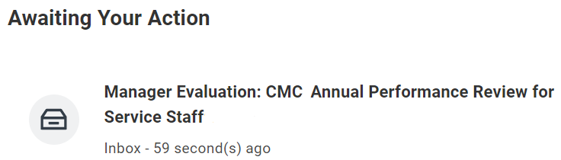
- Locate the task named Manager Evaluation: CMC Annual Performance Review for Service Staff and click Get Started to start the manager evaluation.
- Complete the manager evaluation sections:
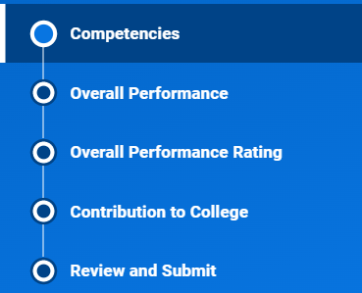

Competencies
- Please review your direct report’s responses in the Competencies section.
- For each Competency, please select a rating in the Proficiency Rating field. Note: The employee’s response to each competency will be visible to you.
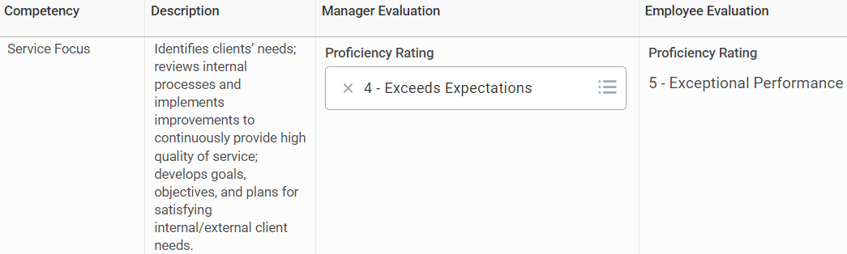
- Once you have provided the Proficiency Rating for each Competency, the competency ratings will be averaged in the Manager Summary section.
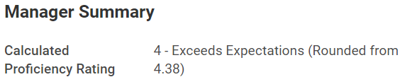
- The Competencies section includes a Comment box, where you can add explanations and additional notes on your rating, as well as provide specific examples from the evaluation period.
- Click Next when finished rating the Competencies.

Overall Performance
- Please review and provide a response to your direct report’s Answer in the Overall Performance section.
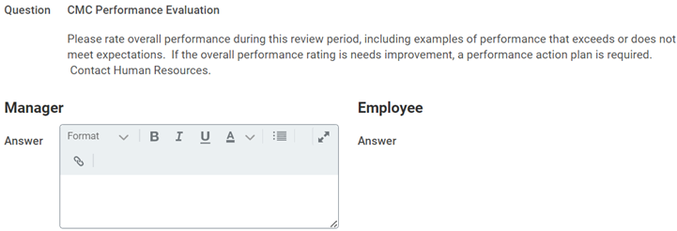
- In the Manager Summary, select a rating in the Rating field.
  - Note that the corresponding Rating Description will appear for the selected rating.
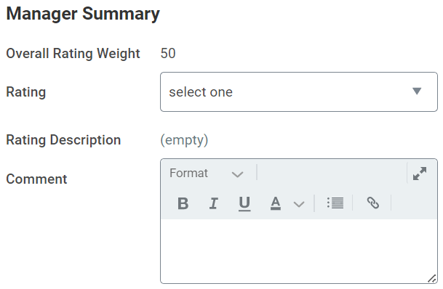
- Click Next when finished rating the Overall Performance.

Overall Performance Rating
- In the Overall Performance Rating section, you will see the calculated average of the ratings that were provided in the Competencies and Overall Performance sections.
- You may also provide any concluding thoughts or comments regarding your direct report’s performance to support your rating.
- Click Next when complete.

Employee Contribution to College
- Please review and provide a response to your direct report’s Answer in the Employee Contribution to College section.
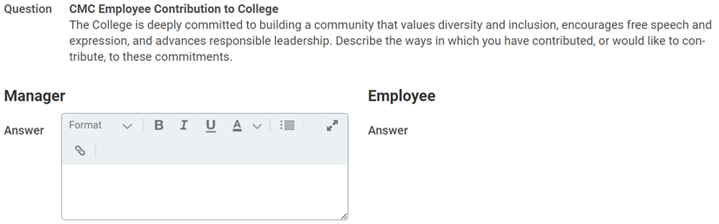
- Click Next when complete.

Review and Submit
- Please review your responses to the manager evaluation for completeness and accuracy.
  - If you need to make updates to any responses, you may do so by clicking on the section in the left-hand navigation menu.
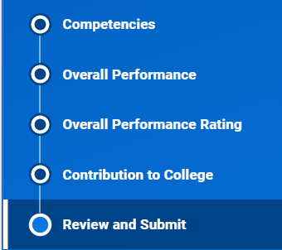
- When you are finished making updates to your direct report’s review and are ready to submit, click Submit.

Next Steps
- The performance review will now route to your manager to further review your direct report’s evaluation. Once this is complete, the performance review will route to CMC Human Resources.
- Once the performance review is fully completed and approved, you will receive a reminder in Workday to coordinate a time to meet with your direct report to discuss the evaluation.
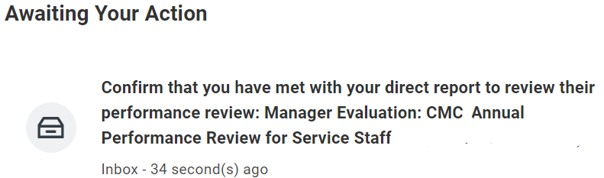
- After you meet with your direct report, your direct report will receive a task in Workday to acknowledge the review. Once your direct report acknowledges their review, you will receive a new task in Workday.
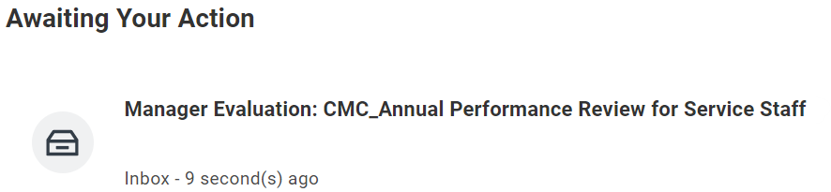
- Open the new task (Provide Employee Review Comments) and click Get Started
- You will have one last opportunity to review your direct report’s performance evaluation in the Summary Section.
- After you have reviewed your direct report’s performance evaluation and have had the opportunity to discuss it with them, please Acknowledge the review by navigating to the Acknowledgement section on the left-hand menu, clicking on the Status drop-down menu, and selecting Acknowledge Review.
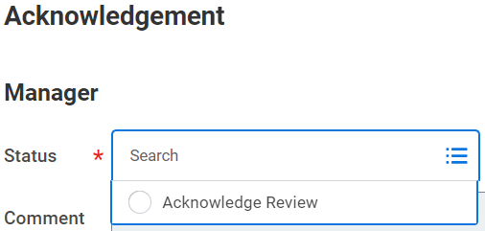
- Click Submit when you are done.

